Joining a Roger’s Session

NOTE: There are three principle access points ZWIFT.com web site, ZWIFT app, and ZWIFT Companion

Requirements:
- ZWIFT account and app
- ZWIFT COMPANION app (available only on phones, iPad, or other tablet devices)
- A trainer or other Bluetooth device that can pair with ZWIFT

Put the workouts into your ZWIFT app (using your desktop, laptop or other device)
- Download the workout files from your e-mail (from youngstraining@gmail.com)
- Put the workout files on your desktop for easy access
- Go to your hard drive on your device
  - Go to your Documents/ZWIFT/Workouts folder
  - Drag the workout files (you’ve placed on your desktop) into the above folder

Confirm the workouts are in your ZWIFT Custom workout library
- Open the ZWIFT app
- After you’ve paired your trainer, you should be sent to the ride page
- Look for workouts at the top of the ride page
- Click on workouts then “custom workouts”
- Check the workouts to confirm Youngs Training workouts are there
  - Scroll down to see all of the workouts

NOTE: You can ride any of Youngs workouts at any time on any ZWIFT course.

Getting an invitation to a Rogers Session “meetup”
- Go to the ZWIFT Companion and follow youngs training
- If your account is current; you will receive an invitation to join the meetup
- Look on ZWIFT Companion EVENTS (at the bottom of your Companion home page)
- You should see the youngs training event
- Confirm you are attending

NOTE: Whether you confirm or not you will see the meetup when you start the ZWIFT app and arrive at the ride page

Joining the meetup
- Start the ZWIFT app (10 minutes prior to the start of the meetup)
- When you get to the ride page click on the meetup box
- ZWIFT will load the ride course and display your avatar on the side of the road. As you pedal your avatar should pedal also.
- Look on the lower right to see what workout we’ll be doing
- Click on the lower left of the screen to bring up the Menu icon
- Click on the Menu icon then the top right of the screen you’ll see Workouts
- Click on Workouts and select from the custom library the workout we will do
- Click on BACK on the bottom of the screen and you’ll be sent back onto the side of the road
- The workout table should be displayed on the top left of the screen.
- The Countdown to the start is in the top middle of the screen,
- At the start your avatar will ride onto the road and the meetup will start

NOTE (starting sooner than 10 minutes): If you start sooner than 10 minutes; your avatar will begin riding on the road but you’ll see a message at the bottom of the screen alerting you to join the meetup. When you click on that notice after start minus 10 minutes; you’ll be taken back to the side of the road waiting for the meetup to begin.

NOTE (starting late): If you start too late and the meetup has begun; your avatar will get a boost to catch up with the group. Putting in a workout file at that time will not serve you. Just keep up with the group and follow what they’re doing.

Riding the Session (meetup)
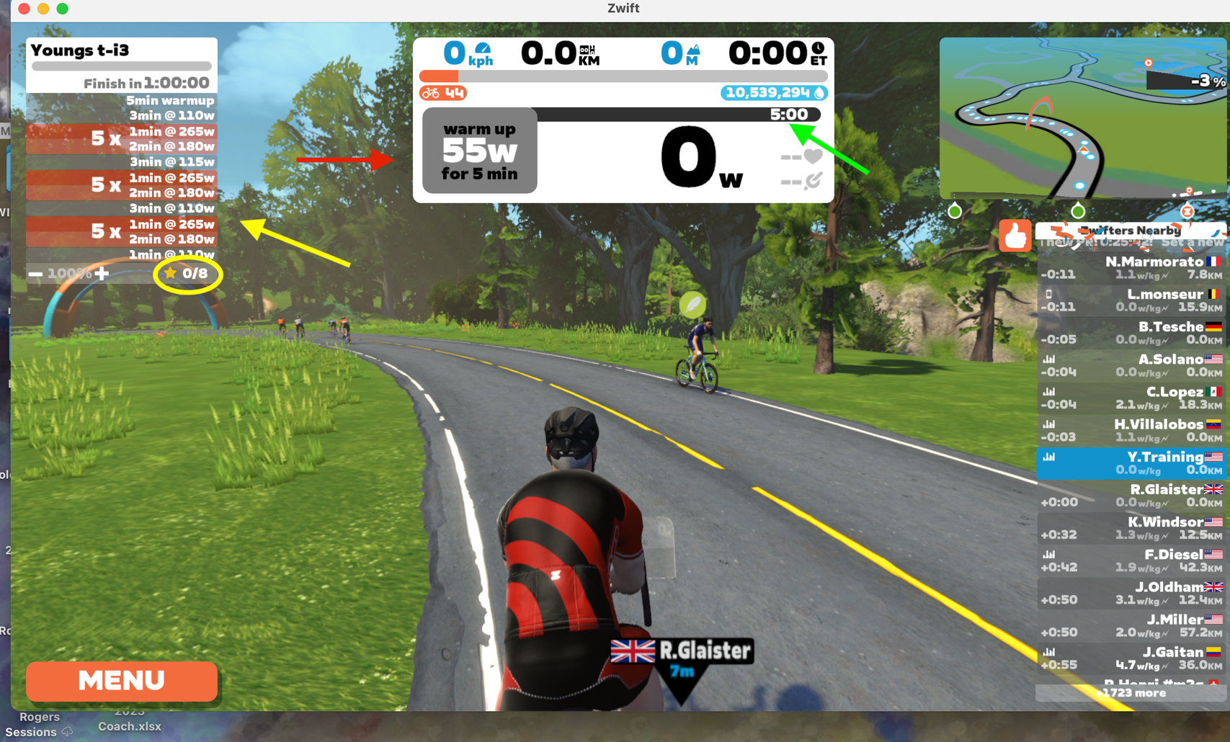
- As you ride and view the screen
  - The red arrow shows the current recommended power
  - The green arrow shows the remaining time for each set
  - The yellow arrow shows where in the workout you are
  - Note the archway; that is where a “change” in your recommended effort begins
  - The yellow circle shows the number of gold stars you’ve achieved for the session
    - Each gold star means you’ve complied perfectly with the workout power recommendation for each set
- When the ride is over save the session

Coaching: If you would like for me to review your workouts; join or follow Youngs Training on Connect Garmin or Strava. Go to ZWIFT.com, then to your profile, then to connections and connect with Garmin or Strava (or both). If I am connected or following you; I’ll see your workout pages and will note that I’ve looked at them (and left messages when appropriate).

Here’s a short video showing the above process:
https://www.youtube.com/watch?v=dwkyCBrJzYg

